 Project Report

On

“Child Behavior in Crime data”

***Submitted in partial fulfilment of the requirements for the award of the degree of***

**MASTER OF COMPUTER APPLICATIONS (MCA)**

**BY**

KAVYANJALI K B

CU23MCA0021A

UNDER THE GUIDANCE OF

PROFESSOR

KRISHNAN R

Department of School of Engineering

**Report on Crime Data Analysis System**

**Abstract**

The Crime Data Analysis System is a progressive java application whose primary function is to facilitate the analysis and rendering of crime data from CSV files. This tool is mainly intended to allow its users to analyse crime statistics and trends in a user-friendly manner without the need of contacting statisticians. The system incorporates an easily navigable graphical user interface created with Java Swing; the users can upload crime data, compare the counts of incidents in different years, and visualize data by using bar charts that can be easily modified according to the user’s preferences.

It is implemented to use JFreeChart for data visualization where users can create and analyse different types of charts which demonstrates the crime incidents at different time intervals. This capability is crucial in pattern analysis and in defining trends and irregularities in numbers pertaining to crime. Also, as part of trend analysis, the system composes facilities for calculating average variations in the number of incidents and defining whether related incidents are growing or shrinking over time.

Thus, the Crime Data Analysis System addresses the practical application of crime analytics and went beyond its functionality in a simple user interface. The system is intended for general use with various levels of available users namely researchers, policy makers and public safety actors to increase usability with the aim of making the interpretation of data and decision making easier and efficient. The application of the system is able to import, compare, visualize and specify the crime trend analysis data in one application which is advantageous for both, the user friendly and the powerful crime analysis.

**Introduction**

Knowledge of the patterns of crime is essential for purposes of identifying the right preventive measures, distributing resources as well as making new policies. However, the examination of the crime statistics is a common practice that may include a set of steps and methodologies which are rather challenging for a common user to perform. This often involves statistical software as well as high level analytical techniques to which many people may not easily have access.

The challenges of ineffective data management and analysis and presentation of crime data are tackled by the Crime Data Analysis System as presented below. This system is developed in Java and it uses the Java Swing package to design a friendly user interface (GUI) to manage users’ operations with the data. The interface has text boxes for the user to input the crime data in the form of CSV files, sliders for setting the conditions to compare data and graphs for displaying the data set.

Thus, one of the system conventions implemented is to search and compare crime incidents from one year to another. Users can for instance input the different crime types and in a bid to compare incident counts, they can select specific years. This feature is useful in that it enables one to see trends of events and how the crime rates go up or down. Not only that, it also came with a very comprehensive data visualization method which employs the use of the JFreeChart library which is famous for its powerful charting system. It enables users to produce bar graphs on crime incident trends to enable them to easily identify patterns.

It also provides trend analysis as part of the system which enables users to know the average rate of change in the crime incidents for several years. This analysis is crucial in as much as it aids in trends analysis and the use of data to make future decisions.

Thus, the Crime Data Analysis System which appends these features into a single application, unburdens the process of crime data analysis tremendously. By providing general public with an opportunity to get direct access to crime statistics, it enables them to plan for required actions and improvements in crime prevention to be made by combining their knowledge and efforts. At the same time, this approach enhances the coverage of crime data and enables the decisions’ makers to monitor and utilize the crime data after its thorough analysis in the form of meaningful and graphical information.

**Literature Survey**

Several tools and methodologies exist for analysing crime data. Traditional statistical software like SPSS and R provide extensive analytical capabilities but require significant expertise. Geographic Information Systems (GIS) such as ArcGIS offer spatial analysis but are often complex and expensive. Recent advancements in data visualization tools and libraries, like JFreeChart, make it easier to present data in a more comprehensible format. The Crime Data Analysis System integrates these modern techniques into a user-friendly application, bridging the gap between complex data analysis and accessible user interfaces.

**Existing Tools and Technologies**

**SPSS:** A powerful statistical tool used for data analysis but requires specialized knowledge.

**R:** An open-source software environment for statistical computing and graphics.

**ArcGIS:** A GIS for mapping and spatial analysis.

**JFreeChart:** A Java library for creating a wide range of charts, including bar charts and line charts.

**Java Swing:** A part of Java Foundation Classes (JFC) used for building graphical user interfaces.

**Importance of Custom Solutions**

Custom solutions like the Crime Data Analysis System offer tailored functionalities specific to user needs. Unlike off-the-shelf tools, custom applications can be designed to address unique requirements, such as specific data formats, user interaction models, and reporting needs. Custom solutions enhance usability, streamline processes, and offer greater control over data handling and presentation.

**Methodology**

The development of the Crime Data Analysis System involved several key steps:

**1. Requirement Analysis:** Identifying the core functionalities needed for crime data analysis, including data upload, comparison, visualization, and trend analysis.

**2. System Design:** Designing a user-friendly interface and defining the data processing and visualization components.

**3. Implementation:** Coding the application using Java Swing for the GUI and JFreeChart for data visualization.

**4. Testing:** Ensuring the application performs accurately and handles various input scenarios.

**User Requirements**

**Data Upload:** Ability to upload CSV files containing crime data.

**Comparison:** Compare incidents for a specific crime head across different years.

**Visualization:** Generate charts to visualize crime data over time.

**Trend Analysis:** Analyse trends in crime incidents over multiple years.

**Error Handling:** Display meaningful error messages and user feedback.

**Design**

The system comprises the following components:

**1. User Interface:** Designed using Java Swing, the interface includes input fields for crime head and years, and buttons for uploading files, comparing data, visualizing, and analysing trends.

**2. Data Processing:** Includes CSV parsing and data storage in `Crime Record` objects.

**3. Data Visualization:** Uses JFreeChart to create bar charts representing crime incidents.

**4. Trend Analysis:** Calculates average changes in crime incidents to determine trends.

**Implementation**

The implementation involves:

**Reading CSV Files:** Parsing CSV files to extract crime records.

User Interface: Creating a Swing-based interface with buttons and text fields.

**Data Visualization:** Generating bar charts using JFreeChart based on user input.

**Trend Analysis:** Calculating average changes in incidents and providing trend analysis results.

**Testing**

The system was tested to ensure:

Correct Data Parsing: Valid and invalid CSV formats are handled appropriately.

**Functional Accuracy:** The compare, visualize, and trend analysis functionalities work as intended.

**User Interface:** All user inputs and actions are processed correctly, and meaningful error messages are displayed.

Testing involved both unit tests for individual components and integration tests to ensure the entire system functions cohesively.

**Coding**

import java.awt.*;

import java.awt.event.*;

import java.io.*;

import java.util.*;

import java.util.List;

import java.util.stream.Collectors;

import javax.swing.*;

import org.jfree.chart.ChartFactory;

import org.jfree.chart.ChartPanel;

import org.jfree.chart.JFreeChart;

import org.jfree.data.category.DefaultCategoryDataset;

public class CrimeDataAnalysis2 {

static class CrimeRecord {

String crimeHead;

int year;

int incidents;

CrimeRecord(String crimeHead, int year, int incidents) {

this.crimeHead = crimeHead;

this.year = year;

this.incidents = incidents;

}

}

public static List<CrimeRecord> readCSV(String filePath) {

List<CrimeRecord> records = new ArrayList<>();

String line = "";

String splitBy = ",";

try (BufferedReader br = new BufferedReader(new FileReader(filePath))) {

// Skip the header line

br.readLine();

while ((line = br.readLine()) != null) {

String[] data = line.split(splitBy);

try {

String crimeHead = data[0].trim(); // Assuming the first column is the crime head

for (int i = 1; i < data.length; i++) {

int year = 2001 + i - 1; // Assuming years start from 2001 and are consecutive

int incidents = Integer.parseInt(data[i].trim());

records.add(new CrimeRecord(crimeHead, year, incidents));

}

} catch (NumberFormatException e) {

System.err.println("Skipping invalid record: " + Arrays.toString(data));

}

}

} catch (IOException e) {

e.printStackTrace();

}

return records;

}

public static class UserInputFrame extends JFrame implements ActionListener {

JTextField year1Field, year2Field, crimeHeadField;

JButton compareButton, uploadButton, visualizeButton, trendButton;

List<CrimeRecord> records;

String filePath;

UserInputFrame() {

setLayout(new FlowLayout());

uploadButton = new JButton("Upload CSV");

add(uploadButton);

uploadButton.addActionListener(this);

add(new JLabel("Enter Crime Head:"));

crimeHeadField = new JTextField(15);

add(crimeHeadField);

add(new JLabel("Enter first year:"));

year1Field = new JTextField(5);

add(year1Field);

add(new JLabel("Enter second year:"));

year2Field = new JTextField(5);

add(year2Field);

compareButton = new JButton("Compare");

add(compareButton);

compareButton.addActionListener(this);

visualizeButton = new JButton("Visualize Data");

add(visualizeButton);

visualizeButton.addActionListener(this);

trendButton = new JButton("Analyze Trend");

add(trendButton);

trendButton.addActionListener(this);

setSize(600, 300);

setTitle("Crime Data Analysis");

setDefaultCloseOperation(JFrame.EXIT_ON_CLOSE);

setVisible(true);

}

public void actionPerformed(ActionEvent e) {

if (e.getSource() == uploadButton) {

JFileChooser fileChooser = new JFileChooser();

int returnValue = fileChooser.showOpenDialog(null);

if (returnValue == JFileChooser.APPROVE_OPTION) {

File selectedFile = fileChooser.getSelectedFile();

filePath = selectedFile.getAbsolutePath();

records = readCSV(filePath);

showMessageDialog("File uploaded successfully!");

}

} else if (e.getSource() == compareButton) {

try {

if (records == null || records.isEmpty()) {

showErrorDialog("Please upload a CSV file first.");

return;

}

String crimeHead = crimeHeadField.getText().trim();

int year1 = Integer.parseInt(year1Field.getText());

int year2 = Integer.parseInt(year2Field.getText());

performComparison(crimeHead, year1, year2);

} catch (NumberFormatException ex) {

showErrorDialog("Please enter valid years.");

}

} else if (e.getSource() == visualizeButton) {

if (records == null || records.isEmpty()) {

showErrorDialog("Please upload a CSV file first.");

return;

}

visualizeData();

} else if (e.getSource() == trendButton) {

if (records == null || records.isEmpty()) {

showErrorDialog("Please upload a CSV file first.");

return;

}

analyzeTrend();

}

}

private void performComparison(String crimeHead, int year1, int year2) {

List<CrimeRecord> recordsYear1 = records.stream()

.filter(r -> r.crimeHead.equalsIgnoreCase(crimeHead) && r.year == year1)

.collect(Collectors.toList());

List<CrimeRecord> recordsYear2 = records.stream()

.filter(r -> r.crimeHead.equalsIgnoreCase(crimeHead) && r.year == year2)

.collect(Collectors.toList());

if (recordsYear1.isEmpty() || recordsYear2.isEmpty()) {

showErrorDialog("Data for the specified crime head and years is not available.");

return;

}

int incidentsYear1 = recordsYear1.get(0).incidents;

int incidentsYear2 = recordsYear2.get(0).incidents;

String result = String.format(

"Crime Head: %s\n" +

"Year %d: Incidents: %d\n" +

"Year %d: Incidents: %d\n",

crimeHead, year1, incidentsYear1,

year2, incidentsYear2);

showResultDialog(result);

}

private void visualizeData() {

String crimeHead = crimeHeadField.getText().trim();

if (crimeHead.isEmpty()) {

showErrorDialog("Please enter a Crime Head to visualize.");

return;

}

DefaultCategoryDataset dataset = new DefaultCategoryDataset();

// Filter and add data to the dataset for the specified crime head

for (CrimeRecord record : records) {

if (record.crimeHead.equalsIgnoreCase(crimeHead)) {

dataset.addValue(record.incidents, record.crimeHead, String.valueOf(record.year));

}

}

// Check if the dataset is empty (i.e., no data for the specified crime head)

if (dataset.getRowCount() == 0) {

showErrorDialog("No data available for the specified crime head.");

return;

}

// Create the chart

JFreeChart barChart = ChartFactory.createBarChart(

"Crime Data Visualization for " + crimeHead,

"Year",

"Number of Incidents",

dataset

);

// Create and display the chart panel

ChartPanel chartPanel = new ChartPanel(barChart);

JFrame chartFrame = new JFrame("Crime Data Visualization");

chartFrame.setDefaultCloseOperation(JFrame.DISPOSE_ON_CLOSE);

chartFrame.getContentPane().add(chartPanel);

chartFrame.pack();

chartFrame.setVisible(true);

}

private void analyzeTrend() {

String crimeHead = crimeHeadField.getText().trim();

if (crimeHead.isEmpty()) {

showErrorDialog("Please enter a Crime Head to analyze the trend.");

return;

}

// Filter records for the specified crime head and sort by year

List<CrimeRecord> filteredRecords = records.stream()

.filter(r -> r.crimeHead.equalsIgnoreCase(crimeHead))

.sorted(Comparator.comparingInt(r -> r.year))

.collect(Collectors.toList());

if (filteredRecords.isEmpty()) {

showErrorDialog("No data available for the specified crime head.");

return;

}

// Calculate the trend by finding the average increase/decrease in incidents

int totalDifference = 0;

for (int i = 1; i < filteredRecords.size(); i++) {

int difference = filteredRecords.get(i).incidents - filteredRecords.get(i - 1).incidents;

totalDifference += difference;

}

double averageDifference = (double) totalDifference / (filteredRecords.size() - 1);

String trendResult = String.format("Trend Analysis for Crime Head: %s\n", crimeHead);

if (averageDifference > 0) {

trendResult += String.format("On average, the number of incidents is increasing by %.2f per year.", averageDifference);

} else if (averageDifference < 0) {

trendResult += String.format("On average, the number of incidents is decreasing by %.2f per year.", Math.abs(averageDifference));

} else {

trendResult += "The number of incidents is stable over the years.";

}

showResultDialog(trendResult);

}

private void showErrorDialog(String message) {

JOptionPane.showMessageDialog(this, message, "Error", JOptionPane.ERROR_MESSAGE);

}

private void showResultDialog(String message) {

JOptionPane.showMessageDialog(this, message, "Result", JOptionPane.INFORMATION_MESSAGE);

}

private void showMessageDialog(String message) {

JOptionPane.showMessageDialog(this, message, "Message", JOptionPane.INFORMATION_MESSAGE);

}

}

public static void main(String[] args) {

SwingUtilities.invokeLater(() -> new UserInputFrame());

    }

}

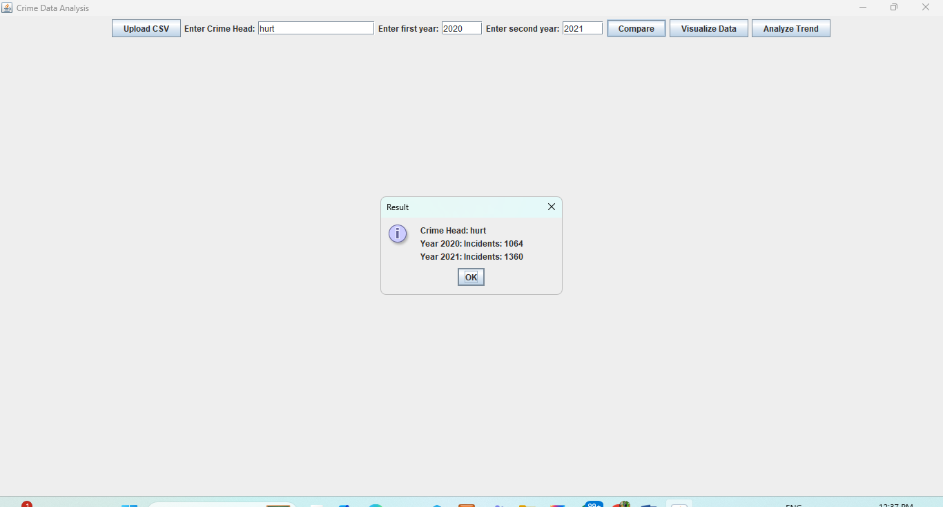

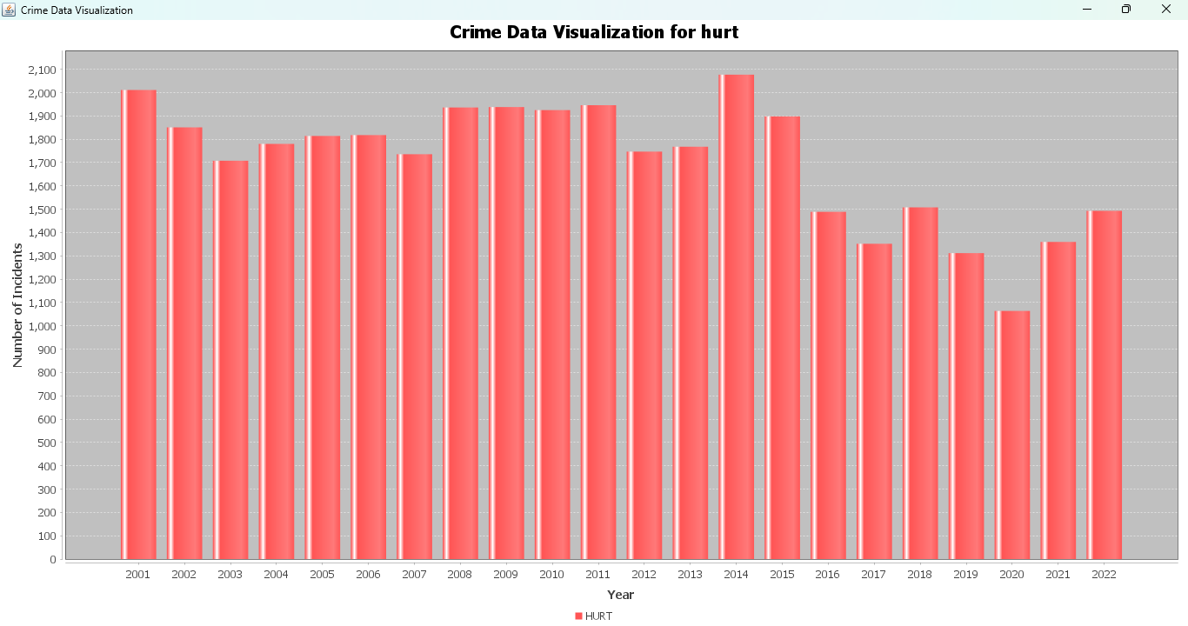

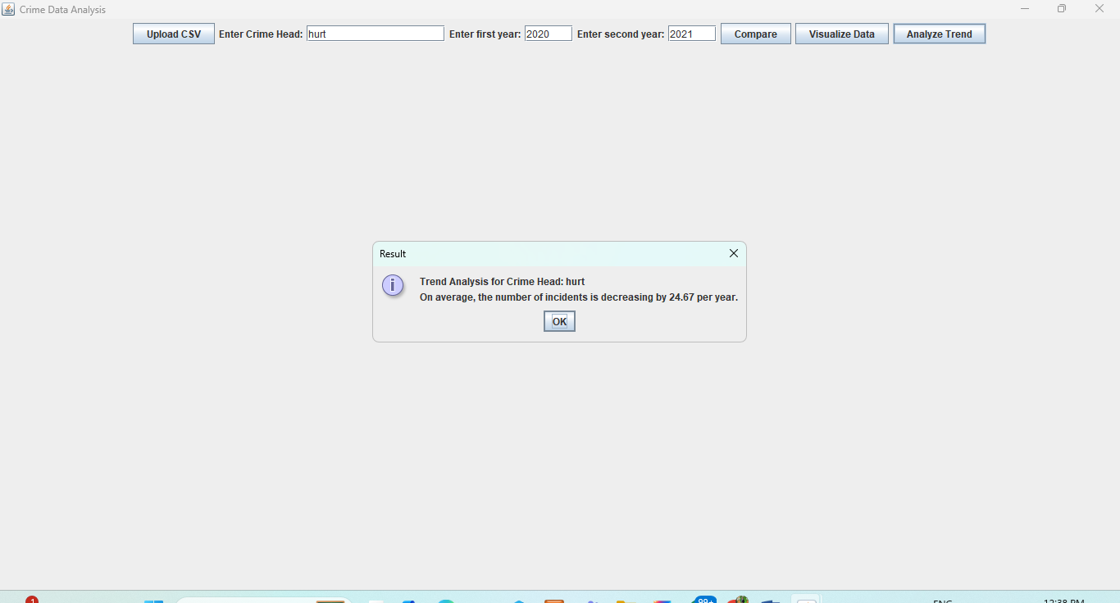

**Results**

The system successfully allows users to:

Upload and parse CSV files.

Compare crime incidents between two years.

Visualize crime data through bar charts.

Analyse trends in crime incidents over time.

Feedback from users indicated that the system is intuitive and provides valuable insights into crime data.

**Future Enhancements**

Enhanced Visualization: Implement additional chart types (e.g., line charts, pie charts) for more detailed data representation.

Advanced Analytics: Integrate more sophisticated analytical techniques such as regression analysis and clustering.

User Customization: Allow users to customize chart colours, styles, and formats.

Data Import/Export: Support additional data formats and sources for more flexible data handling.

Performance Optimization: Improve the efficiency of data processing and visualization for larger datasets.

**Conclusions**

The Crime Data Analysis System effectively addresses the need for a user-friendly tool to analyse and visualize crime data. By leveraging Java Swing for the user interface and JFreeChart for data visualization, the system provides a comprehensive solution for comparing crime incidents, visualizing data trends, and performing trend analysis. The system’s design and implementation reflect a balance between functionality and ease of use, making it a valuable tool for users seeking to understand crime patterns and trends.

**References**

1. Oracle. (n.d.). *Java Platform, Standard Edition Documentation*. Retrieved from <https://docs.oracle.com/javase/>
2. Oracle. (n.d.). *The Swing Tutorial*. Retrieved from <https://docs.oracle.com/javase/tutorial/uiswing/>
3. Object Refinery Limited. (n.d.). *JFreeChart: A Java Chart Library*. Retrieved from http://www.jfree.org/jfreechart/
4. Javanica. (n.d.). *How to Read and Write CSV Files in Java*. Retrieved from https://www.baeldung.com/java-csv
5. Few, S. (2009). *Now You See It: Simple Visualization Techniques for Quantitative Analysis*. Analytics Press.
6. Field, A. (2013). *Discovering Statistics Using IBM SPSS Statistics*. Sage Publications.
7. Esri. (n.d.). *What is GIS?*. Retrieved from https://www.esri.com/en-us/what-is-gis/overview
8. R Core Team. (2023). *R: A Language and Environment for Statistical Computing*. Retrieved from <https://www.r-project.org/>
9. Bostock, M., Ogievetsky, V., & Heer, J. (2011). *D3: Data-Driven Documents*. IEEE Transactions on Visualization and Computer Graphics, 17(12), 2301-2309.
10. Sommerville, I. (2016). *Software Engineering*. 10th Edition. Pearson.
11. Bloch, J. (2018). *Effective Java*. 3rd Edition. Addison-Wesley.
12. Oracle. (n.d.). *Java I/O*. Retrieved from <https://docs.oracle.com/javase/tutorial/essential/io/>
13. Oracle. (n.d.). *Java Streams API*. Retrieved from <https://docs.oracle.com/javase/8/docs/api/java/util/stream/package-summary.html>
14. Bloch, J. (2008). *Effective Java*. Addison-Wesley.
15. Oracle. (n.d.). *JDBC Basics*. Retrieved from <https://docs.oracle.com/javase/8/docs/technotes/guides/jdbc/>
16. Shneiderman, B., & Plaisant, C. (2010). *Designing the User Interface: Strategies for Effective Human-Computer Interaction*. 5th Edition. Pearson.
17. Sommerville, I. (2011). *Software Engineering*. 9th Edition. Pearson.
18. Tukey, J. W. (1977). *Exploratory Data Analysis*. Addison-Wesley.
19. Cleveland, W. S. (1994). *The Elements of Graphing Data*. 2nd Edition. Hobart Press.
20. Tufte, E. R. (2001). *The Visual Display of Quantitative Information*. 2nd Edition. Graphics Press.
21. Murphy, K. P. (2012). *Machine Learning: A Probabilistic Perspective*. MIT Press.
22. Data Format Standards. (n.d.). *Common Data Formats and Standards*. Retrieved from <https://www.dataformats.org/>
23. Norman, D. A. (2013). *The Design of Everyday Things*. Basic Books.
24. Finkel, H. (2014). *Java Performance: The Definitive Guide*. O'Reilly Media.
25. Sierra, K., & Bates, B. (2005). *Head First Java*. O'Reilly Media.
26. Dalgaard, P. (2008). *Introductory Statistics with R*. Springer.
27. Kimball, R., & Ross, M. (2011). *The Data Warehouse Toolkit: The Definitive Guide to Dimensional Modeling*. Wiley.
28. Stallings, W. (2013). *Computer Security: Principles and Practice*. 3rd Edition. Pearson.
29. Kieran, H. (2017). *Comparing Data Visualization Tools*. Retrieved from https://www.dataviz.com/comparison
30. Weisburd, D., & Braga, A. A. (2019). *Police Innovation and Crime Prevention: Lessons Learned from Police Research over the Past 20 Years*. Cambridge University Press.